COLOURS OF LIGHT Name: __________________________

Light is made up of different colours. A spectrum of colours (like a rainbow).
In 1666, Sir Isaac Newton shone a beam of light through a prism (a clear plastic 3D triangle) and observed a band of colours appearing on a screen.
The colours were violet, indigo, blue, green, yellow, orange and red.
From this Newton concluded that white light was a mixture of various coloured mixed in certain proportions.
He called this band of colours a spectrum and the splitting of white light into colours is called dispersion.
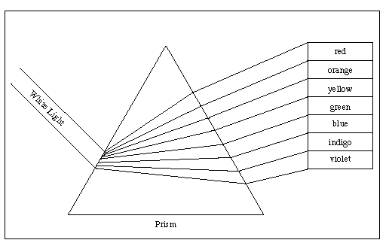
Colour in the spectrum below in the correct colours.
Each colour of light is different because it has a different wavelength.
For example, red light has a longer wavelength than violet.

- White light is made up of seven different _______________ of light.
- A prism is a special lens that separates white light.
- If an object reflects yellow light, you see the object as ____________________.
- The colours that an object absorbs are the colours that it takes in.
- A green leaf absorbs all of the colours except for ______________.
- You see an object as the colour of the light it reflects.

Lights can pass through objects or be reflected by objects.
Experiment – Creating a spectrum

Materials – light box, piece of white paper, triangular prism.

1. Arrange the light box so that a single slit of light shines upon a triangular prism.
2. Put the prism on a piece of white paper.
3. Move the prism around until you form a spectrum of light.
3. Trace the prism on the paper and colour in the spectrum.
4. Try using different size slits, different prisms and more than one prism.
5. Each person in the group should draw/colour in a different spectrum.
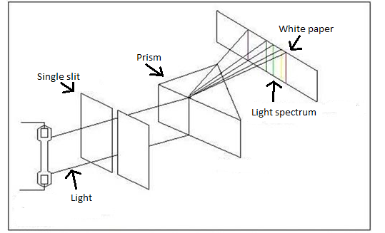

Light can also go into objects and not come out – this is called being absorbed.
So when light hits something it can:
- Pass through the object – for example ___________________________________.
- Be reflected by the object – for example __________________________________.
- Be absorbed by the object – for example _________________________________.

In the space provided draw a picture of a red apple. Show all the colours of white light hitting the apple like a rainbow. Show that the only colour being reflected is red.

TYPES OF OBJECTS
Opaque materials do not allow light to pass through them. They either block or absorb the light.
Transparent materials allow all light to pass through it.
Translucent materials let some light through.
Material | Opaque, transparent or translucent

REFLECTION OF LIGHT
(Fill in the blanks using page 127 of text book)
Reflection is the __________________ of light off a __________________. Some surfaces appear ______________, like a mirror and you can see an ________________ in them.
This type of ____________________ is called _______________ reflection.
Regular reflection occurs because the reflecting surface is very ______________.
If the surface is not perfectly smooth, then the light will reflect in
________________directions and is called ____________________ reflection.

Objects can be seen because light reflects from them into the eye. The rays of light follow the following rule.

LAW OF REFLECTION

The angle of incidence = the angle of reflection.

REGULAR AND DIFFUSE REFLECTION

Regular reflection - parallel rays of light that hit a smooth surface are reflected parallel to each other.

e.g. mirror, polished silver

Diffuse reflection - parallel light rays hitting a rough surface are reflected in all directions (the light is scattered).

e.g. newspaper, sandpaper, "matt" paint on walls.

REFRACTION

Refraction is the bending of light that sometimes happens as light passes through one substance and into another.
Demonstration – Radiometer
Materials – radiometer, torch
A simple instrument that is made of four vanes of aluminium foil that spin on a needle point inside a glass globe from which most of the air has been removed. One face of each vane is blackened, while the other side is bright. When placed in sunlight or near any light, the vanes rotate in the direction faced by the bright sides. The black surface absorbs the heat and radiates (gives off) heat while the bright surface reflects heat.

Look at a pencil in a beaker of water, see how the pencil looks as though it has been bent?
The light bends as it moves into the water.



